Data Presentation and Analysis
2.1 Graduation Profile
The total number of students graduated from the campus during the year 2022 were 287. Out of those 287 students, 45 got BBS degree, 63 got BBM degree, 157 got MBS degree and 22 students got MBA-BF degree. Among those graduates, there were 24 male and 21 female students in BBS program; 25 male and 38 female students in BBM program; 53 male and 104 female students in MBS program; 8 male and 14 female students in MBA-BF program. In total, 110 male and 177 female students graduated from the college during the year 2022. The details are shown in the table 2.1 and the same is presented in the bar chart in Figure 2.1.
Table 2.1
Students graduated from the campus during the year 2022.
 |  | Program Completed |  |  |  | Total
 |  | BBS | BBM | MBS | MBA-BF | Total
Gender | Male | 24 | 25 | 53 | 8 | 110
Gender | Female | 21 | 38 | 104 | 14 | 177
Total |  | 45 | 63 | 157 | 22 | 287

Figure 2.1
Students graduated from the campus during the year 2022
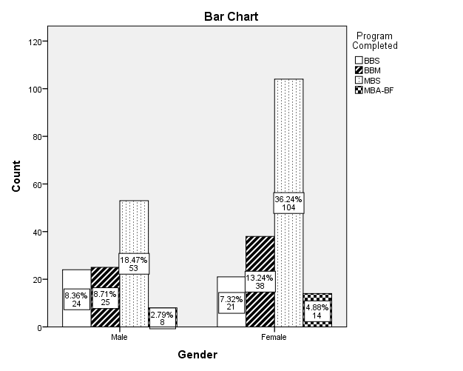

2.2 Further study status of the graduates
Table 2.2 illustrates the further study status of students as a whole. 11 BBS graduates, 14 BBM graduates and 1 MBS graduates are enrolled for the higher studies. As BBS graduates are concerned 1 student is enrolled in MBA program and 10 students are enrolled in MBS program. Similarly, 4 BBM graduates are enrolled in MBA program, 19 students in MBS program and 2 in MA programs. Further, only 1 MBS graduate is enrolled in MBA program. Thus, in total 26 graduates from BBS, BBM and MBS degree are pursuing higher education while there is no record of MBA-BF students getting higher studies.
Table 2.2
Graduates further study status
 |  | Graduates further study status |  |  | Total
 |  | MBA | MBS | MA | Total
Program Completed | BBS | 1 | 10 | 0 | 11
Program Completed | BBM | 4 | 8 | 2 | 14
Program Completed | MBS | 1 | 0 | 0 | 1
Total |  | 6 | 18 | 2 | 26

Fig No 2.2
Graduates further study status
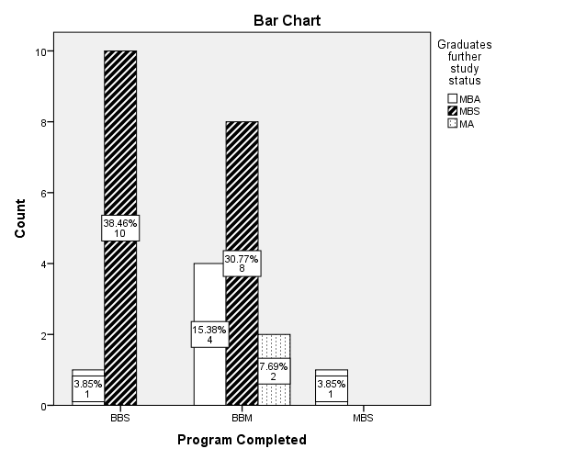
2.3 Employment status of the MBS graduates
The employment status of the students graduated in BBS, BBM, MBS and MBA-BF programs from the campus is stated in the table 2.3. Out of total 45 BBS graduates, 6 are doing service in different organizations and 39 are unemployed. Similarly, in total 63 students graduated from BBM program, no evidence of employment in the organization or self-employment is recorded. As MBS graduates are considered, it is found that 26 graduates are providing their service in different organization and 18 are unemployed. Further, 4 MBA-BF graduates is working in organization and 18 are unemployed. Thus, as a whole, 36 graduates are working for organizations and 251 are unemployed. There is no record of self-employment among the graduates.
Table 2.3
Current Employment Status
 |  | Current Employment Status |  | Total
 |  | Service in an Organization | Unemployed | Total
Program Completed | BBS | 6 | 39 | 45
Program Completed | BBM | 0 | 63 | 63
Program Completed | MBS | 26 | 131 | 157
Program Completed | MBA-BF | 4 | 18 | 22
Total |  | 36 | 251 | 287

Figure 2.3
Current Employment Status
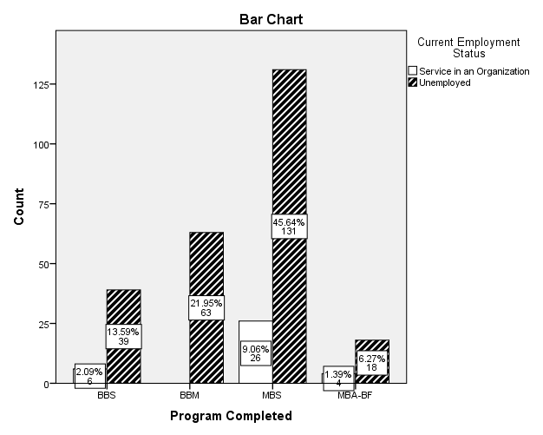

2.4 Nature of Organization in which graduates are employed
The graduates from the campus are involved in different types of organizations. 3 graduates from BBS, 14 from MBS and 2 from MBA-BF are employed in private organization. Similarly, 1 graduate from BBS, 5 from MBS and 1 from MBA-BF are engaged in public organization. Whereas, 2 graduate from BBS, 7 from MBS and 1 from MBA-BF are employed in government organization. As NGO/INGO is considered, no record of employment was found. Thus, all together 19 graduates are employed in private organization, 7 in public organization, and 10 in government organization. The detail information is given in the table 2.4 and the figure 2.4 also depicts the same.
Table 2.4
Nature of Organization where graduates are employed
 |  | Organization Type |  |  | Total
 |  | Private | Public | Government | Total
Program Completed | BBS | 3 | 1 | 2 | 6
Program Completed | MBS | 14 | 5 | 7 | 26
Program Completed | MBA-BF | 2 | 1 | 1 | 4
Total |  | 19 | 7 | 10 | 36

Figure 2.4
Nature of Organization where graduates are employed
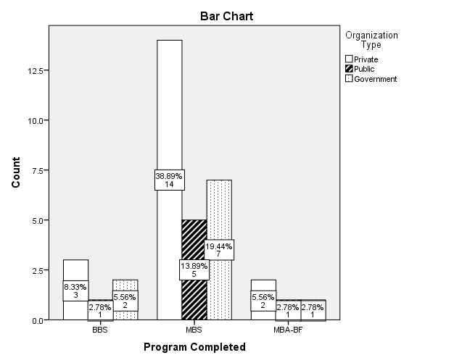
2.5 Nature of Employment of Graduates
Table 2.5 depicts the nature of employment in which graduates are engaged in the organization. From the BBS, MBS and MBA-BF programs, 6, 25 and 3 graduates respectively, are employed in the organization on full time basis. Whereas, 1 graduate from each MBS program and MBA-BF program were found to work on part-time basis. Thus, in total 34 graduates are employed as full time and 2 are employed as part-time. As BBM graduates are considered, no evidence of employment is recorded.
Table 2.5
Nature of Employment of Graduates
 |  | Employment Type |  | Total
 |  | Full Time | Part Time | Total
Program Completed | BBS | 6 | 0 | 6
Program Completed | MBS | 25 | 1 | 26
Program Completed | MBA-BF | 3 | 1 | 4
Total |  | 34 | 2 | 36

Figure 2.5
Nature of Employment of Graduates
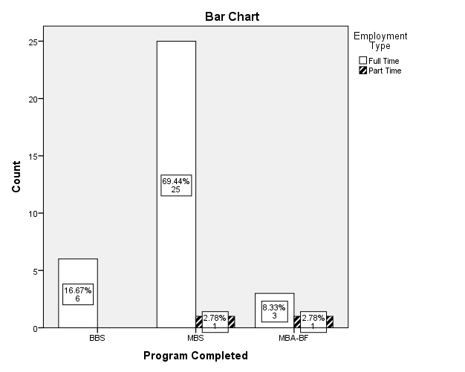

2.6 Relevance of the program

The table 2.6 depicts the response of the graduates from BBS, BBM, MBS and MBA-BF program of the campus regarding the relevance of their respective program to their professional requirement. The mean value of the response of the graduates from BBS, BBM, MBS and MBA-BF are found to be 3.98, 3.51, 3.67 and 3.73 respectively. From these statistics, it can be inferred that all the programs are relevant to the professional requirements of students to some extent since all the mean value are inclined towards 4 which indicates good in the measurement scale. As a total, the mean value of 3.69 infers that the programs in the campus are satisfactory to the level it provides practical relevance to the professional career of the graduates.
Table 2.6
Quality and Relevance of the program

Statement | Program Completed | Mean | N | Std. Deviation
Relevance of the program to your professional (job) requirement | BBS | 3.98 | 45 | 1.097
 | BBM | 3.51 | 63 | 1.061
 | MBS | 3.67 | 157 | 1.173
 | MBA-BF | 3.73 | 22 | .985
 | Total | 3.69 | 287 | 1.128

2.7 Programs’ contribution to graduates’ professional and personal development (gender Wise)

To check the programs’ contribution to graduates’ professional and personal development according to gender, the independent t-test is performed as shown in table 2.7. From the table the p-values for work placement/attachment/internship is found to be smaller than 0.05 which infers that there is significant difference in the opinion of male and female with regard to the statements: work placement, attachment and internship. The mean value for male and female graduates with regard to work placement, attachment and internship are 3.73 and 3.39 respectively which indicates that the male graduates has better perception than the female graduates about the placement , attachment and internship facilities provided by the campus.
However, the p-value for extracurricular activities and problem solving ability are 0.974 and 0.157 respectively which is greater than 0.05 which infers that there is no difference in the perception of male and female with regard to extracurricular activities and problem solving ability.
Above all the statements, problem solving ability has highest mean value: 4.00 for male and 3.82 for female which infer that the problem solving ability provided in different programs as compared to other activities has satisfactory result than other activities according to the response of graduates. As overall contribution of the programs offered is considered, there is no significant difference in the perception between male and female. The mean value for male and female are 3.8182 and 3.6441 which infers that both male and female are satisfied with contribution of programs in their professional and personal development.
Table 2.7
Programs’ Contribution (Gender Wise)

 | Gender | Mean | Std. Deviation | t-value | p-value
Extracurricular activities | Male | 3.73 | 1.091 | .033 | 0.974
Extracurricular activities | Female | 3.72 | .981 | .033 | 0.974
Problem solving ability | Male | 4.00 | 1.084 | 1.418 | 0.157
Problem solving ability | Female | 3.82 | 1.029 | 1.418 | 0.157
Work placement/ attachment /internship | Male | 3.73 | 1.226 | 2.158 | 0.032
Work placement/ attachment /internship | Female | 3.39 | 1.382 | 2.158 | 0.032
Overall Contribution | Male | 3.8182 | .96486 | 1.534 | 0.126
Overall Contribution | Female | 3.6441 | .91604 | 1.534 | 0.126

2.8 Programs’ Contribution to graduates’ professional and personal development (Program Wise)

For identifying the contribution to graduates’ professional and personal development by different programs in the Campus One-way Anova statistics is used as shown in the table 2.8. From the table, it is found that the p-value for extracurricular activities and problem solving ability are less than 0.05 which infers that there is significant difference between the programs (BBS, BBM, MBS and MBA-BF) regarding the extracurricular activities and problem solving ability. The mean value of extracurricular activities for BBS and BBM are 4.40, 4.10 respectively which are higher as compared to mean value of MBS (3.52) and MBA-BF (3.50). Thus, it can be inferred that with regard to extracurricular activities for students’ professional development, BBS and BBM graduates are more satisfied as compared to MBS and MBA-BF programs. Among all the programs BBS students are highly satisfied and MBA-BF are least satisfied regarding the extracurricular activities.
Similarly, the mean value of problem solving ability for BBS is 4.31 which is higher as compared to mean value of BBM (3.73), MBS (3.86) and MBA-BF (3.68). Thus, it can be inferred that with regard to problem solving ability of students’, BBS graduates are more satisfied as compared to BBM, MBS and MBA-BF programs. Among all the programs BBS students are highly satisfied and MBA-BF are least satisfied regarding the problem solving ability.
Further, the p-value for work placement/attachment/internship is 0.281, which is greater than 0.05, which indicates that there is no significant difference between different programs with respect work placement/attachment/internship. All the programs have equal contribution to work placement, attachment and internship.
As overall, BBS program is found to have greater contribution to graduate professional and personal development while MBA-BF program have least contribution as compared to other programs.
Table 2.8
Programs’ Contribution (Program Wise)

 |  | Mean | Std. Deviation | F-value | P-value
Extracurricular activities | BBS | 4.04 | .928 | 7.194 | .000
Extracurricular activities | BBM | 4.10 | .640 | 7.194 | .000
Extracurricular activities | MBS | 3.52 | 1.084 | 7.194 | .000
Extracurricular activities | MBA-BF | 3.50 | 1.225 | 7.194 | .000
Problem solving ability | BBS | 4.31 | 1.083 | 3.297 | .021
Problem solving ability | BBM | 3.73 | .954 | 3.297 | .021
Problem solving ability | MBS | 3.86 | 1.053 | 3.297 | .021
Problem solving ability | MBA-BF | 3.68 | 1.086 | 3.297 | .021
Work placement/attachment/internship | BBS | 3.84 | 1.348 | 1.282 | .281
Work placement/attachment/internship | BBM | 3.57 | 1.187 | 1.282 | .281
Work placement/attachment/internship | MBS | 3.43 | 1.341 | 1.282 | .281
Work placement/attachment/internship | MBA-BF | 3.36 | 1.590 | 1.282 | .281
Overall Contribution | BBS | 4.0667 | .97079 | 3.476 | .016
Overall Contribution | BBM | 3.7989 | .72473 | 3.476 | .016
Overall Contribution | MBS | 3.6008 | .96701 | 3.476 | .016
Overall Contribution | MBA-BF | 3.5152 | 1.03242 | 3.476 | .016

2.9 Teaching/Learning, teacher-student relationship and educational delivery efficiency

The table 2.9 depicts the teaching/learning environment, teacher-student relationship and educational delivery efficiency in the campus in the perspective of students. From the table, it can be clearly identified that the mean values of teaching/learning environment, quality of education delivered and teacher student relationship are 4.24, 4.24 and 4.31 respectively. From this, it can be inferred that the teaching/learning environment, quality of education delivered and teacher student relationship are good in the campus because the mean value is near to 4 (leveled good in the scale). As compared to all the statement, response of student regarding teaching learning environment and quality of education delivered are better, followed by teacher student relationship. Thus as a whole, it can be inferred that the environment of the campus regarding teaching and learning, socialization and efficiency is satisfactory.
Table 2.9
Teaching/Learning, Teacher-Student Relationship and Educational Delivery Efficiency

Statements | N | Mean | Std. Deviation
Teaching/ Learnig environment | 287 | 4.24 | .950
Quality of education delivered | 287 | 4.24 | .862
Teacher student relationship | 287 | 4.31 | .871
Valid N (listwise) | 287

2.10 Facilities of Library, Laboratory, Canteen, Sports and Urinals

For the learning and hygienic environment, good facilities of library, laboratory, canteen, sports and urinals are the most important factors. To understand the level of such environment provided by campus, the response from the graduated student were collected. The response is clearly depicted in the table 2.10, where we find that the mean value of library facility, lab facility, sports facility and Canteen/Urinals are 4.20, 3.53, 3.69, and 3.61 respectively. From these statistics, it can be inferred that, such facilities provided by the campus are good because all the values are inclined towards 4 (leveled good in the measurement scale). Thus, as a whole, the statistics from the response of graduates shows that the campus is providing the facilities of library, laboratory, canteen, sports and urinals at a satisfactory level.
Table 2.10
Facilities of Library, Laboratory, Canteen, Sports and Urinals
Statements | N | Mean | Std. Deviation
Library Facility | 287 | 4.20 | 1.016
Lab Facility | 287 | 3.53 | 1.386
Sports Facility | 287 | 3.69 | 1.209
Canteen/Urinals etc | 287 | 3.61 | 1.244
Valid N (listwise) | 287

Major Findings

From the analysis of the data collected from the response of students regarding different aspects of the campus, the study has following major findings:
- Out of total 287 graduates from the campus in BBS, BBM, MBS and MBA-BF programs, only 26 students are pursuing higher studies. As concerned to BBS graduates, out of 45 graduates, 1 is enrolled in MBA program and 10 in MBS program. Similarly, out of 63 BBM graduates, 4 are enrolled in MBA, 8 in MBS and 2 in MA program. Further, out of 157 MBS graduates, only 1 graduate is pursuing MBA degree. Whereas, as far as MBA-BF graduates are concerned, neither a single students is found to be pursuing their higher study.
- When employment status of graduates is considered, 36 students are employed to organizations (6 from BBS, 26 from MBS and 4 from MBA-BF) and the rest 251 students are unemployed. Thus, 12.5 percent of total graduates are employed and remaining 6887.5 percent are unemployed.
- Most of the graduates who are employed are working in the private sector which accounts to be 19. Out of these 19 graduates working in private company 3 are from BBS, 14 from MBS and 2 from MBA-BF. In public organizations, 7 graduates are working, where 1 is from BBS, 5 from MBS and 1 from MBA-BF. Similarly in government organization 10 graduates are working, where 2 is from BBS, 7 from MBS and 1 from MBA-BF. As long as nature of employment is concerned, total 34 graduates are full time employee (6 from BBS, 25 from MBS and 3 from MBA-BF) and 2 graduates are working in part time basis (1 from MBS and 1 from MBA-BF).
- With respect to the program’s relevance to their professional requirements, BBS graduates had given better response followed by MBA-BF and MBS graduates. Whereas, BBM graduates have provided average response about the practicality of the programs in their career. As a whole, the programs in the campus are satisfactory to the level it provides practical relevance to the professional career of the graduates.
- It is found that there is significant difference in the opinion of male and female with regard to the work placement, attachment and internship. The mean statistics according to the response of male and female graduates suggest us that the male graduates are more satisfied than female graduates with regard to work placement, attachment and internship provided by the campus. As problem solving ability and extracurricular activities are concerned, there is no difference in the perception of male and female. In average, all the activities have satisfactory contribution to professional and individual development both male and female. Whereas, as these activities are compared, problem solving ability provided in different programs of the campus has better result to both male and female graduates than extracurricular activities and work placement/attachment/internship.
- With regard to extracurricular activities for students’ professional development, BBS and BBM graduates are more satisfied as compared to MBS and MBA-BF programs. Among all the programs, BBS students are highly satisfied and MBA-BF are least satisfied . Similarly, with regard to problem solving ability of students’, BBS graduates are more satisfied as compared to BBM, MBS and MBA-BF programs. Among all the programs, BBS students are highly satisfied and MBA-BF are least satisfied. Further, with regard to work placement/attachment/internship, there is no significant difference between different programs with respect work placement/attachment/internship. All the programs have equal contribution to work placement, attachment and internship. As overall, BBS program is found to have greater contribution to graduate professional and personal development while MBA-BF program have least contribution as compared to other programs.
- It is found that the teaching/learning environment, quality of education delivered and teacher student relationship are good in the campus because the mean value is above 4 (leveled good). In average the response of students regarding all the statements are similar. Thus as a whole, the environment of the campus regarding teaching and learning, socialization and efficiency is satisfactory.
- It is found from the mean statistics of library facility, lab facility, sports facility and Canteen/Urinals provided by the campus are good because all the values are inclined towards 4 (leveled good in the measurement scale). Thus, as a whole, the statistics from the response of graduates shows that the campus is providing the facilities of library, laboratory, canteen, sports and urinals at a satisfactory level.

